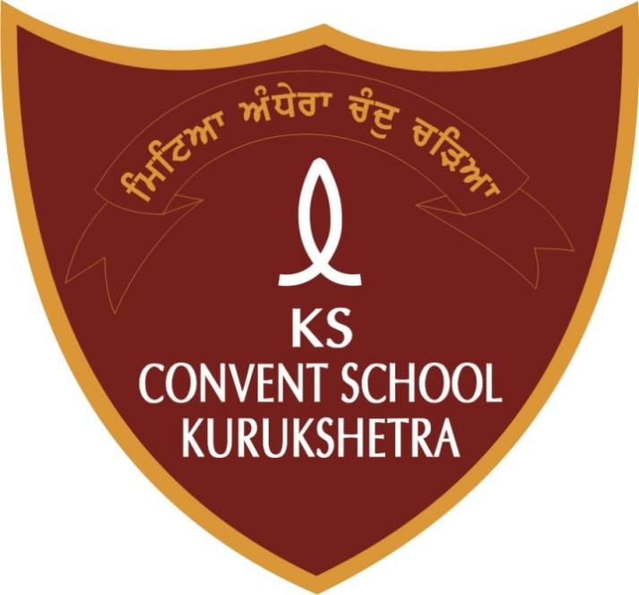
ACADEMIC PLANNER 2024-2025
CLASSES I - V
APRIL 2024
MONDAY | TUESDAY | WEDNESDAY | THURSDAY | FRIDAY | SATURDAY | SUNDAY
1 | 2 | 3 | 4 | 5 | 6 | 7
8 | 9 | 10 | 11  Id –ul-Fitr | 12 | 13 | 14  Dr. B.R  Ambedkar  Jayanti
15 | 16 | 17  Ram Navami | 18 | 19  IV-V Weave a story | 20
22Earth Day  celebration  I-III ART COMPETITION  IV-V DANCE COMPETITION  (INTER HOUSE COMPETITION) | 23 | 24 | 25 | 26  I-III BAG ARRANGEMENT | 27 | 28
29 | 30

MAY 2024
MONDAY | TUESDAY | WEDNESDAY | THURSDAY | FRIDAY | SATURDAY | SUNDAY
 |  | 1 | 2 | 3 I ENG (R)  II ENG (R)  III ART  IV ART  V ART | 4 | 5
6  I-III card making on Mother’s Day  IV-V Activity on Mother’s Day | 7 | 8 | 9  I HINDI (R)  II HINDI (R)  III -V G.K | 10  Parshuram Jayanti | 11  Mother’s Day celebration  PTM | 12
13 | 14 | 15 | 16 | 17  I ART  II COMPUTER  III COMPUTER  IV PUNJABI  V SST | 18 | 19
20 | 21 | 22 | 23 | 24  I COMPUTER  II ART  III SCIENCE  IV ENG  V SCIENCE | 25 | 26
27 | 28 | 29 | 30  I ENGLISH  II ENGLISH  III SST  IV SCIENCE  V ENGLISH | 31

JUNE 2024
MONDAY | TUESDAY | WEDNESDAY | THURSDAY | FRIDAY | SATURDAY | SUNDAY
 |  |  |  |  | 1  Summer  Vacation | 2  Summer  Vacation
3  Summer  Vacation | 4  Summer  Vacation | 5  Summer  Vacation | 6  Summer  Vacation | 7  Summer  Vacation | 8  Summer  Vacation | 9  Summer  Vacation
10  Summer  Vacation | 11  Summer  Vacation | 12  Summer  Vacation | 13  Summer  Vacation | 14  Summer  Vacation | 15  Summer  Vacation | 16  Summer  Vacation
17  Summer  Vacation | 18  Summer  Vacation | 19  Summer  Vacation | 20  Summer  Vacation | 21  Summer  Vacation | 22  Summer  Vacation | 23  Summer  Vacation
24  Summer  Vacation | 25  Summer  Vacation | 26  Summer  Vacation | 27  Summer  Vacation | 28  Summer  Vacation | 29  Summer  Vacation | 30  Summer  Vacation
JULY 2024
MONDAY | TUESDAY | WEDNESDAY | THURSDAY | FRIDAY | SATURDAY | SUNDAY
1 | 2 | 3 | 4 | 5  I MATHS  II MATHS  III HINDI  IV SST  V COMPUTER | 6 | 7
8 | 9 | 10 | 11 | 12  I HINDI  II HINDI  III ENGLISH  IV COMPUTER  V MATHS | 13  PARENTS TEACHER MEETING (FOR ALL CLASSES) | 14
15  IV Brain Teaser  V Solo Dance competition | 16 | 17 | 18 | 19 I EVS  II EVS  III MATHS  IV HINDI  V PUNJABI | 20 | 21
22  I-III POEM RECITATION  IV -V COLLAGE MAKING  (INTER HOUSE COMPETITION) | 23 | 24 | 25 | 26 I G.K  II G.K  III PUNJABI  IV MATHS  V HINDI  School Tree Day celebration  I-III Plantation activity | 27 | 28
29 | 30 | 31  Shaheed Udham Singh Martyrdom Day

AUGUST 2024
MONDAY | TUESDAY | WEDNESDAY | THURSDAY | FRIDAY | SATURDAY | SUNDAY
 |  |  | 1 | 2 | 3 | 4
5 | 6 | 7  Hariyali Teej | 8 | 9 | 10  PARENTS TEACHER MEETING (FOR ALL CLASSES) | 11
12 | 13 | 14  Independence Day celebration  IV Dance competition | 15  Independence Day | 16  II-III Rakhi Making competition  V Writing competition | 17 | 18
19  Raksha Bandhan | 20 | 21 | 22 | 23  I Fancy dress on Janmashtami | 24 | 25
26  Janmashtami | 27 | 28 | 29 | 30 | 31
SEPTEMBER 2024
MONDAY | TUESDAY | WEDNESDAY | THURSDAY | FRIDAY | SATURDAY | SUNDAY
30  I HINDI  II ENGLISH  III ENGLISH  IV SST  V MATHS |  |  |  |  |  | 1
2 | 3 | 4 | 5  Teacher’s Day celebration | 6 | 7  PARENTS TEACHER MEETING (FOR ALL CLASSES) | 8
9  I-III ARTS | 10 | 11 | 12  I SUPW  II SUPW  III SUPW  IV G.K  V G.K | 13 | 14  I ENG (R)  II ENG (R)  III G.K  IV COMPUTER  V COMPUTER | 15
16 | 17  I HINDI (R)  II HINDI (R)  III COMPUTER  IV ART & SUPW  V ART & SUPW | 18 | 19  I G.K  II COMPUTER  III PUNJABI  IV HINDI  V SST | 20 | 21  I COMPUTER  II G.K  III SCIENCE  IV MATHS  V SCIENCE | 22
23  Shaheedi Divas | 24  I EVS  II EVS  III MATHS  IV PUNJABI  V ENGLISH | 25 | 26  I MATHS  II HINDI  III SST  IV SCIENCE  V HINDI | 27 | 28  I ENGLISH  II MATHS  III HINDI  IV ENGLISH  V PUNJABI | 29
OCTOBER 2024
MONDAY | TUESDAY | WEDNESDAY | THURSDAY | FRIDAY | SATURDAY | SUNDAY
 | 1 I-III CLEAN SPACE COMPETITION  IV-V G.K QUIZ  (INTER HOUSE COMPETITION) | 2  Gandhi Jayanti | 3  Maharaja Agarsain  Jayanti | 4 | 5  PARENTS TEACHER MEETING (FOR ALL CLASSES) | 6
7 | 8 | 9 | 10 | 11  Dusshera | 12  Dusshera | 13
14 | 15 | 16 | 17  Maharishi  Valmiki Jayanti | 18  I ENG (R)  II ENG (R)  III ART  IV ART  V ART | 19 | 20  Karwa Chauth
21 | 22 | 23 | 24 | 25  I HINDI (R)  II HINDI (R)  III G.K  IV G.K  V G.K | 26 | 27
28 | 29Diwali Celebration  I-III Talent Hunt  IV Diya Decoration  V Candle Decoration | 30  Diwali Break | 31  Diwali Break
NOVEMBER 2024
MONDAY | TUESDAY | WEDNESDAY | THURSDAY | FRIDAY | SATURDAY | SUNDAY
 |  |  |  | 1  Diwali Break | 2  Diwali Break | 3  Diwali Break
4 | 5 | 6 | 7 | 8  I ART  II COMPUTER  III COMPUTER  IV MATHS  V SST | 9  PARENTS TEACHER MEETING (FOR ALL CLASSES) | 10
11 | 12 | 13 I COMPUTER  II ART  III SCIENCE  IV ENGLISH  V SCIENCE | 14  Guru Nanak Jayanti / Children Day Celebration  I-III Healthy food competition | 15  Guru Nanak Jayanti | 16 | 17
18 | 19 | 20 | 21 | 22 I ENGLISH  II ENGLISH  III SST  IV SCIENCE  V ENGLISH | 23 | 24
25 | 26 | 27 | 28 | 29  I MATHS  II MATHS  III HINDI  IV SST  V COMPUTER | 30  I-III WRITING COMPETITION  IV-V KHO - KHO MATCH (INTER HOUSE COMPETITION)  IV Science Quiz V Flower Making
DECEMBER 2024
MONDAY | TUESDIAY | WEDNESDAY | THURSDAY | FRIDAY | SATURDAY | SUNDAY
30 | 31 |  |  |  |  | 1
2 | 3 | 4 | 5 | 6  I HINDI  II HINDI  III ENGLISH  IV COMPUTER  V MATHS | 7 | 8
9 | 10 | 11 | 12 | 13  I EVS  II EVS  III MATHS  IV HINDI  V PUNJABI | 14  PARENTS TEACHER MEETING (FOR ALL CLASSES) | 15
16 | 17 | 18 | 19 | 20  I-III G.K  III-IV PUNJABI  V HINDI | 21 | 22
23 | 24  Christmas Day Celebration/Sports Day  I-III Activity on Christmas day  IV Christmas tree  V Santa socks making | 25  Christmas Day | 26 | 27 | 28 | 29
JANUARY 2025
MONDAY | TUESDAY | WEDNESDAY | THURSDAY | FRIDAY | SATURDAY | SUNDAY
 |  | 1  Winter Vacation | 2  Winter Vacation | 3  Winter Vacation | 4  Winter Vacation | 5  Winter Vacation
6  Winter Vacation | 7  Winter Vacation | 8  Winter Vacation | 9  Winter Vacation | 10  Winter Vacation | 11  Winter Vacation | 12  Winter Vacation
13  Winter Vacation | 14  Winter Vacation | 15 | 16 | 17 | 18 | 19
20 | 21 | 22 | 23 | 24  Republic Day  celebration  I-II Role plays on freedom fighter  III-IV Patriotic song competition | 25 | 26  Republic  Day
27 | 28 | 29 | 30 | 31
FEBRUARY 2025
MONDAY | TUESDAY | WEDNESDAY | THURSDAY | FRIDAY | SATURDAY | SUNDAY
 |  |  |  |  | 1 | 2
3 | 4 | 5 | 6 | 7 | 8  PARENTS TEACHER MEETING (FOR ALL CLASSES) | 9
10 | 11 | 12  Guru Ravidas Jayanti | 13 | 14 | 15 | 16
17 | 18 | 19  Saraswati Day celebration | 20  Basant Panchmi | 21 | 22 | 23
24 | 25 | 26  Mahashivratri | 27 | 28
MARCH 2025
MONDAY | TUESDAY | WEDNESDAY | THURSDAY | FRIDAY | SATURDAY | SUNDAY
31 |  |  |  |  | 1 | 2
3 | 4 | 5 | 6 | 7 | 8 | 9
10 | 11 | 12 | 13 | 14  Holi | 15 | 16
17 | 18 | 19 | 20 | 21 | 22 | 23
24 | 25 | 26 | 27 | 28 | 29 | 30

